**INTRODUCTION TO SAP ABAP**

**History Of SAP**

• In 1972, five IBM employees started a company by name SAP AG

• Their objective was to develop a business software or ERP software

• In 1980 the company released the first ERP software by name SAP R/2, where R stands for real time and 2 stands for two tier architecture

• In 1990 the company released advanced version of SAP R/2 by name SAP R/3, where 3 stands for three tier architecture

Even today also we are using SAP R/3

Even today also we are using SAP R/4

**SAP**

SAP: It stands for Systems, Applications and Products in Data Processing

•  It is an ERP software which is used by medium sized as well as top MNC’s

•  SAP supports every business scenario/application commonly used in business

•  SAP supports almost every Business module in the business (around 45+ modules.

•  Very high-cost software

•  It is excellent at integration between all the SAP modules

**What is ABAP:**

ABAP stands for ADVANCED BUSINESS APPLICATION PROGRAMMING LANGUAGE

It is a 4th generation language, that is why it is written as ABAP/4.

The entire ERP software is developed by using a single programming language which is called as ABAP.

Once we have a good knowledge on ABAP, we can work on any SAP module.

**WHAT IS  ERP:**

E:  Enterprise / Company   Ex: Reddy Labs, Reliance, GE, GM, BMW

R:   Resources  
P:  Planning (effective plans for maximum profits with minimum resources)

|  |  |  |
| --- | --- | --- |
| Man | -> | employee |
| Machines | -> | plants/manufacturing units |
| Materials | -> | items/products (raw, semi-finished, finished) |
| Money | -> | finance (profit/loss) |

ERP Software:

A Software which is used to maintain and plan all the business activities of a company/enterprise is called ERP software.

The business activities are :

•  How many customers/vendors/materials

•  How many sales orders/delivery orders/invoice

•  How much profits/loss

•  How many employees/leaves/provident funds/income tax

•  How many plants/stock available/stock damaged etc.

SAP MODULES:

We have various business modules in SAP. Some of them are:

|  |  |  |
| --- | --- | --- |
| SD | : | sales and distribution |
| MM | : | material management |
| FI | : | finance |
| CO | : | controlling |
| HR | : | human resources |
| CRM | : | customer relation management |
| SRM | : | supply relation management |
| SCM | : | Supply chain management |
| APO | : | Advanced Planner and Optimizer |

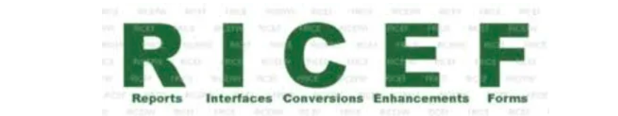

**R-** Report (Classical, Interactive, and ALV Report)

**I-** Interface (IDOC, APIs, and BAPI etc.)

**C -**Conversion (BDC, and BAPI)

**E-** Enhancement (BADI, Customers Exists, etc,)

**F -**Forms (Smart Form and Adobe form)

* **DDIC**
* **REPORTS**
* **MODULEPOOL**
* **ENHANCEMENT**
* **FORMS**
* **BDC**
* **BAPI/RFC**
* **IDOC**
* **OOABAP**
* **ODATA**
* **HANA**